**Institute of Engineering & Management**

**Department of Computer Science & Engineering**

**Object Oriented Programming (IT) Lab for 3rd year 5th semester 2018**

**Code: CS594D**

**Date:** 07/08/18

**WEEK-5**

**Assignment-1**

**Problem Statement:** A typical way to introduce oneself is "Hello, my name is xxx and my hobby is yyy". Arif is a CSE Student at IEM, who secretly moonlights as a hacker. Have Arif introduce himself

1. at a get-together for student leaders of various colleges in Salt Lake
2. at a closed-door Hacker Society meeting
3. at his cousin's birthday party where he meets a beautiful girl who is a Tagore fan.

**Source code:**

import java.util.Scanner;

class Person

{

String name, hobby="Reading";

Person(String n)

{

name=n;

}

}

class Student extends Person

{

Student(String n)

{

super(n);

super.hobby="Facebook";

}

}

class CSE_student extends Student

{

CSE_student(String n)

{

super(n);

super.hobby="Hacking";

}

}

class Main

{

public static void main(String args[])

{

Scanner sc = new Scanner(System.in);

System.out.println("Enter the following command:");

System.out.println(" 1. In Birthday party");

System.out.println(" 2. get-together");

System.out.println(" 3. In closed doors");

int p=sc.nextInt();

System.out.println("Enter Name: ");

switch(p)

{

case 1: Person ob1 = new Person(sc.next());

System.out.println("Hello, my name is "+ob1.name+" and my hobby is "+ob1.hobby+"."); break;

case 2: Student ob2 = new Student(sc.next());

System.out.println("Hello, my name is "+ob2.name+" and my hobby is "+ob2.hobby+"."); break;

case 3: CSE_student ob3 = new CSE_student(sc.next());

System.out.println("Hello, my name is "+ob3.name+" and my hobby is "+ob3.hobby+"."); break;

default:System.out.println("Invalid input!");

}

sc.close();

}

}

**Screen-Shot:**

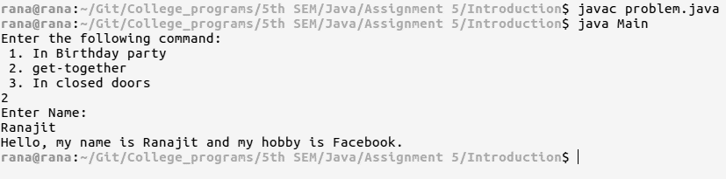

**Fig: output one**

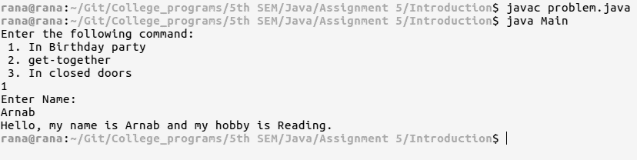

**Fig output two**

**Assignment-2**

**Problem Statement:** Create a class called time that has separate integer member data for hour, minute & second. One constructor should initialize dates to 0 and another should initialize it to fixed values. A main program should create 2 initialized time object and one that is not initialized. then it should add 2 initialized values to store in a third time type variable. finally, it should display the value of the third variable. Take input using Scanner class.

**Source code:**

import java.util.Scanner;

class Time

{

int hour, min, sec;

Time()

{

hour=0;

min=0;

sec=0;

}

Time(int n1, int n2, int n3)

{

hour=n1;

min=n2;

sec=n3;

}

Time add(Time t2)

{

Time t3 = new Time();

t3.sec = (sec+t2.sec);

t3.min = (min+t2.min+t3.sec/60);

t3.hour = (hour+t2.hour+t3.min/60);

t3.sec=t3.sec%60;

t3.min=t3.min%60;

t3.hour=t3.hour%60;

return t3;

}

}

class Main

{

public static void main(String args[])

{

Scanner sc = new Scanner(System.in);

System.out.println("Enter time(hour, min, sec) for 1st obj: ");

Time t1 = new Time(sc.nextInt(),sc.nextInt(),sc.nextInt());

System.out.println("Enter time(hour, min, sec) for 2nd obj: ");

Time t2 = new Time(sc.nextInt(),sc.nextInt(),sc.nextInt());

Time t3 = t1.add(t2);

System.out.println("Resultant time: "+t3.hour+" hour, "+t3.min+" min, "+t3.sec+" sec");

sc.close();

}

}

**Screen-Shot:**

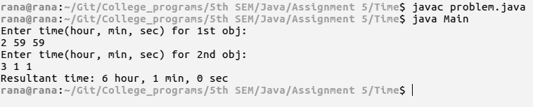

**Fig: output one**

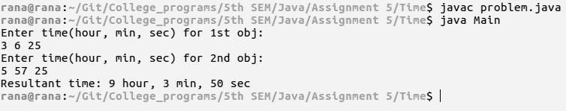

**Fig: output two**